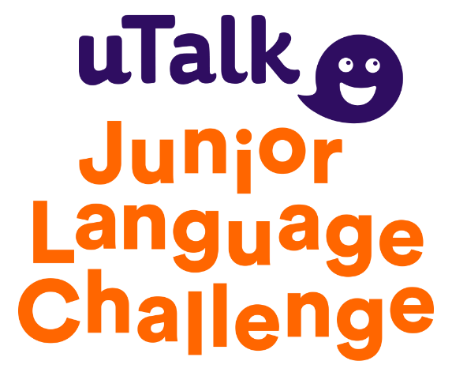

A Guide to the uTalk JLC 2019/20

About the uTalk JLC
Who can take part? What is the uTalk App?

Competition Format
Round One, Round Two, Regional Finals.

Registration Process
Registering, Entry Fees.

Using the uTalk App
System Requirements, Scoring, Learning Offline.

Download the App
iOS, Android, Mac and PC Guides.

Logging in to the App
Student Login Guide

Dashboards
Student, Teacher and Individual Entrant Dashboards

Downloadable Resources
Helpful free materials

Contact
Challenge@utalk.com

About the uTalk JLC
The uTalk Junior Language Challenge (JLC) is a UK-wide competition designed to get children excited about learning languages. uTalk have been running the competition for over 15 years and this year we are introducing some exciting new changes to the previous format.
Who can take part?
The uTalk JLC is open to all UK primary school children who are aged 11 and under on the year of entry to the competition. Entries are invited from schools, and from individuals (if their school isn’t taking part or if they are homeschooled). All participants will learn using the uTalk app.
What is the uTalk App?
Our fantastic app features over 140 languages! Each containing key words and phrases and all voiced by native speakers. Participants of the uTalk JLC will score points in 12 fun topics* In Round One across five progressively challenging games. If they get to Round Two, the topic count goes up to 16 topics.**
The app works on almost any device*** so children can work at home or at school and, because they work independently of each other, children can learn at their own pace. Teachers who register 20 or more children to the uTalk JLC will get access to the app themselves, and can learn along with their pupils. Everybody who registers for the year’s competition (starts in September each year) will have access to their language(s) for the rest of the school year.
Students will need to download the app from their relevant app store or by visiting utalk.com/app and sign in with the username and password we will supply once they are registered. Signing in with these details will gain them access to the 12 uTalk JLC topics for Round one and ensure that their scores are uploaded to their school leaderboards.

* 12 Topics - Starter Words, Holiday, Numbers up to 20, Time, Body, Clothes, Colours, Calendar, Leisure, School, Animals and Fruit.
** 16 Topics - As above, plus La France, Short Phrases, Shopping Phrases, Likes and Dislikes.
*** Works on Mac, PC, iOS, Android, Kindle Fire and most browsers.

Competition Format
The uTalk JLC will be split into 2 rounds and a final for each UK region. Those regions are - Scotland, Wales, Northern Ireland, North East, North West, Yorkshire and Humber, East Midlands, West Midlands, East of England, London, South East and South West.
Round One
The first round will start in September and run until 10am on Friday December 20th 2019. This year schools can choose which language their pupils will learn in Round One from a choice of over 140 available in the uTalk app (with the exception of French, Swedish and Slovak.) To see uTalk’s full language range please visit utalk.com/store. We would like all students at the same school to learn the same language but will consider exceptional cases on request e.g. if one of your pupils is already fluent in the chosen language.
Students need to score at least 500 points (out of a total of 3,960) in Round One to qualify for entry into Round Two. We want to include as many children as possible so this threshold is low enough that we expect most students to make it through to Round Two for their region.
Round Two
Round Two of the uTalk JLC will start at 10am on Monday January 6th 2020. Children who scored enough points in Round One will automatically have French* unlocked on their uTalk account when they log in on this day. As before, teachers who have pupils going through to Round Two will be given a complimentary French account mirroring the children’s.
Round Two will run until 10am on Tuesday 24th March 2020, at which point the 30 highest scorers in each region will qualify for their regional final. In the event of more than 30 children in each region achieving full marks, we will unlock extra French topics for them to learn during a short extension to help select the top 30.
*In exceptional cases, we will consider another language being made available if requested in advance and by email to challenge@utalk.com
Regional Finals
The 30 highest scorers in each region will be invited to go through to a regional final where they will compete against the clock and each other to be named uTalk JLC Champion and Runner-up for their region.
Regional finals will test children on the language they learned in Round Two. The children will compete simultaneously on the uTalk app with ‘live’ scores shown on a leader-board. Venues and timings will be confirmed but we expect them to be held at the start of the Summer Term.
Prizes of gift vouchers will be awarded to regional winners and highest scorers at individual schools will receive certificates of achievement.

Registration Process
Registering
Visit utalk.com/JLC and click the login/register button to create your account. Here you will choose your Round 1 language and create the username and password you’ll use to log in.
Once set up you can sign in and add multiple students via ‘Register Pupils’ tab on the School Dashboard. Each student registered will be given a unique user name and password which they can use to sign in to their uTalk app and start scoring points. These will be supplied to you via the email you used to register your teacher account.
If registering independently from a school the process is the same, simply leave the ‘School Name’ field blank.
Entry Fees
Entry to the uTalk JLC costs only £5 per pupil. This is a flat fee which covers access to the 12 topics on the uTalk app in Round One, plus 16 Topics in Round Two If they score 500 points In Round One. It also covers the cost of the regional finals for those who make it that far. This content will remain available to all pupils until the end of the school year during which they registered, so they can keep on learning.
All teachers will also get a complimentary uTalk account which will mirror the one given to their pupils.
Teachers who register pupils will be sent an invoice to their school in December, once registration for Round One has closed. The amount payable will equal the number of pupils registered x £5. Once registered, this amount is payable regardless of whether a child goes on to use their account or not.
Parents, who enter their children independently of their school, will be asked to pay £5 at the point of registration and before their child’s account goes live.
All money raised from this year’s competition will be put back into developing the competition.
Many thanks to everyone who has supported the uTalk JLC in the past and helped raise more than £100K for our favourite charity onebillion.

The uTalk app works on almost any device, including computers, phones, tablets and web browsers. The app has some ‘minimum requirements’ so the software that your device runs on must be no older than outlined below
System Requirements
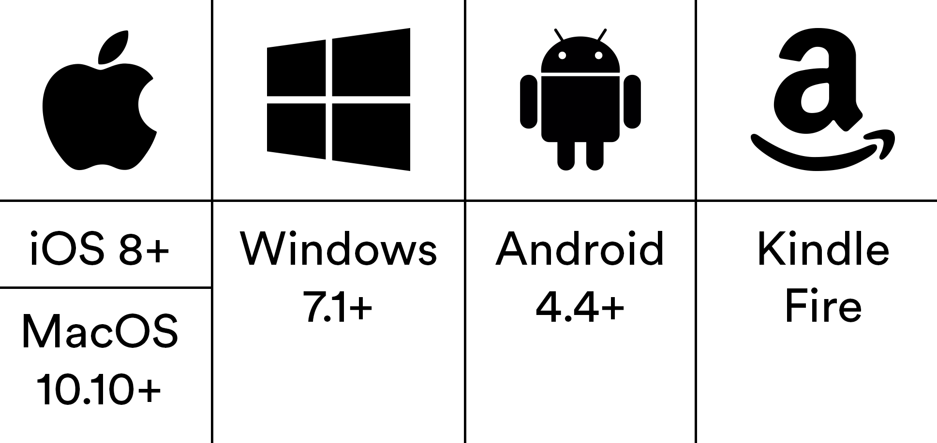
Scoring
Remember, you can sign into the app on all the devices you own, your progress and scores will stay in sync across them all. Just make sure to sign in using the username and password you were given when you registered to ensure any points you score are counted towards your total for the competition.
As part of the uTalk JLC you will receive 12 unlocked topics in the uTalk app. These are Starter Words, Holiday, Numbers up to 20, Time, Body, Clothes, Colours, Calendar, Leisure, School, Animals and Fruit. (Please take care not to confuse Starter Words which is eligible for the competition with First Words which isn’t.)
We will be able to see your score on the dashboard for these topics only. If you download and learn any extra topics, the points from these will not be included on the dashboard total which helps us to track scores for the competition. This means that the score shown in the app and what you see on the dashboard may be different.
The content unlocked within the app as part of the competition is available until the end of the school year (2019/20).
Learning Offline
The uTalk app allows you to download content for use offline. All you have to do is go to the language you are learning and tap on the ‘Download topics’ icon.
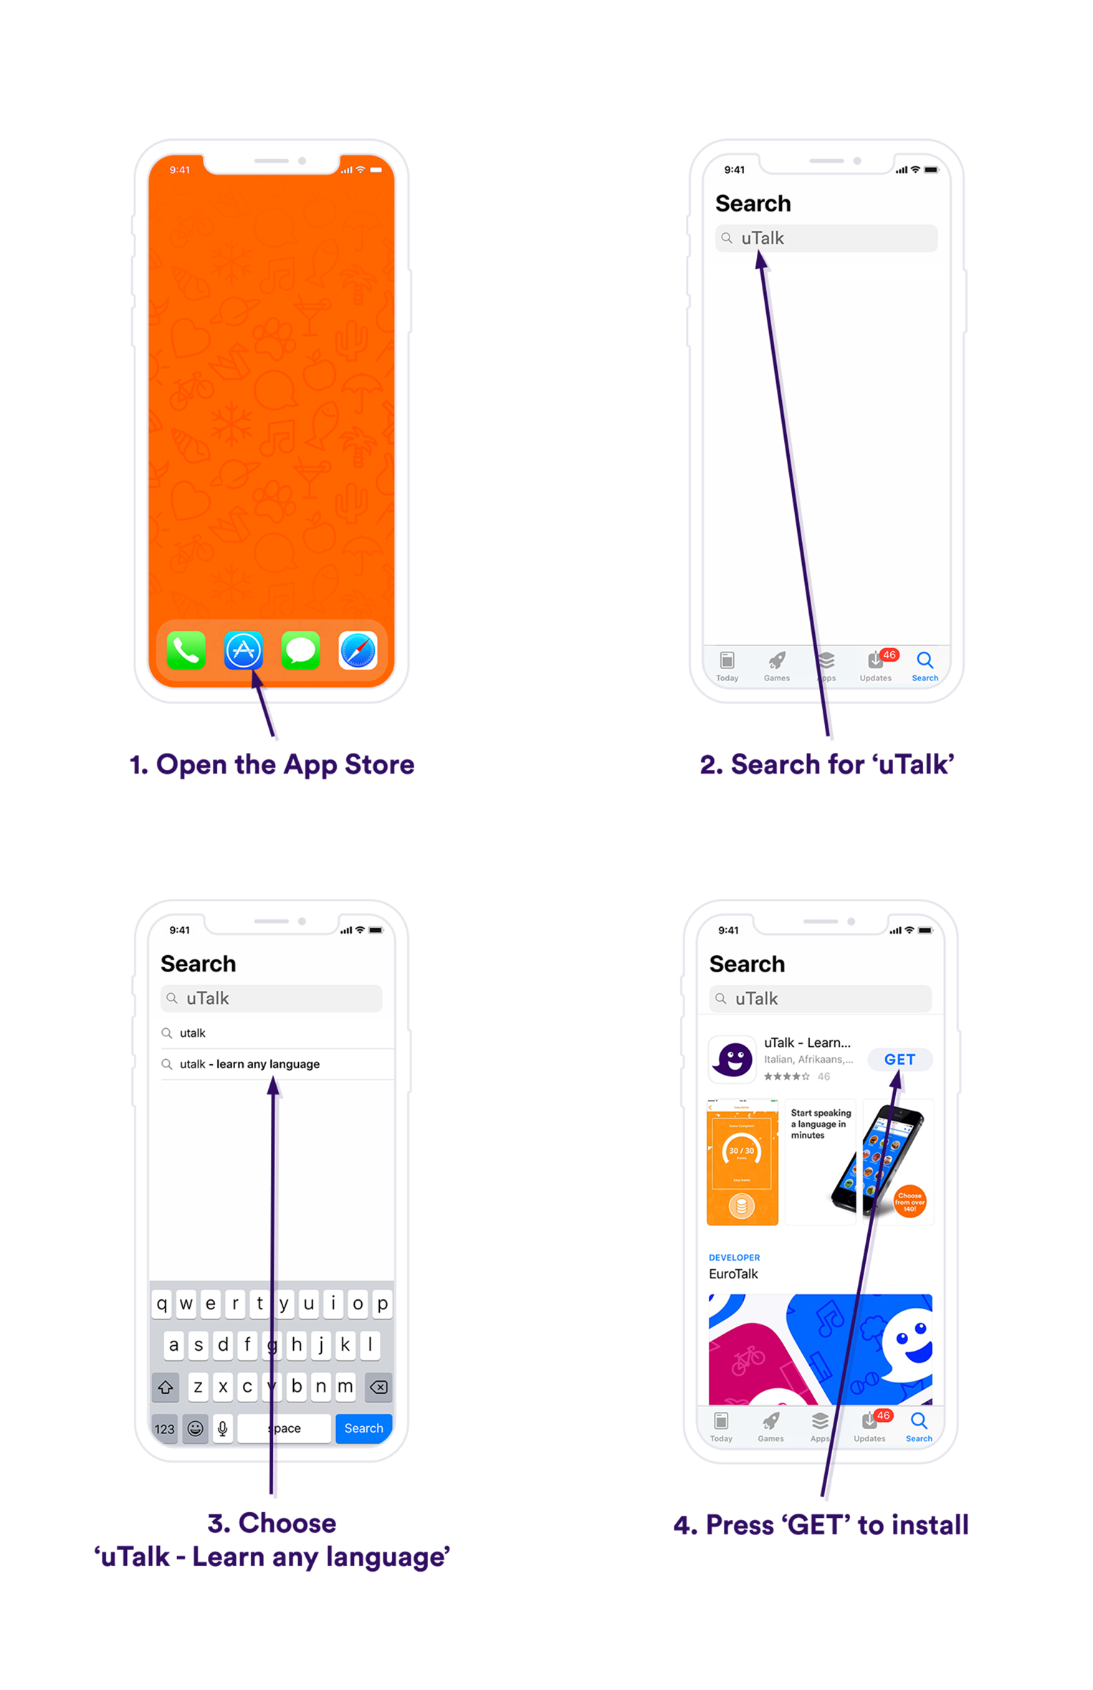
Download the App – iOS

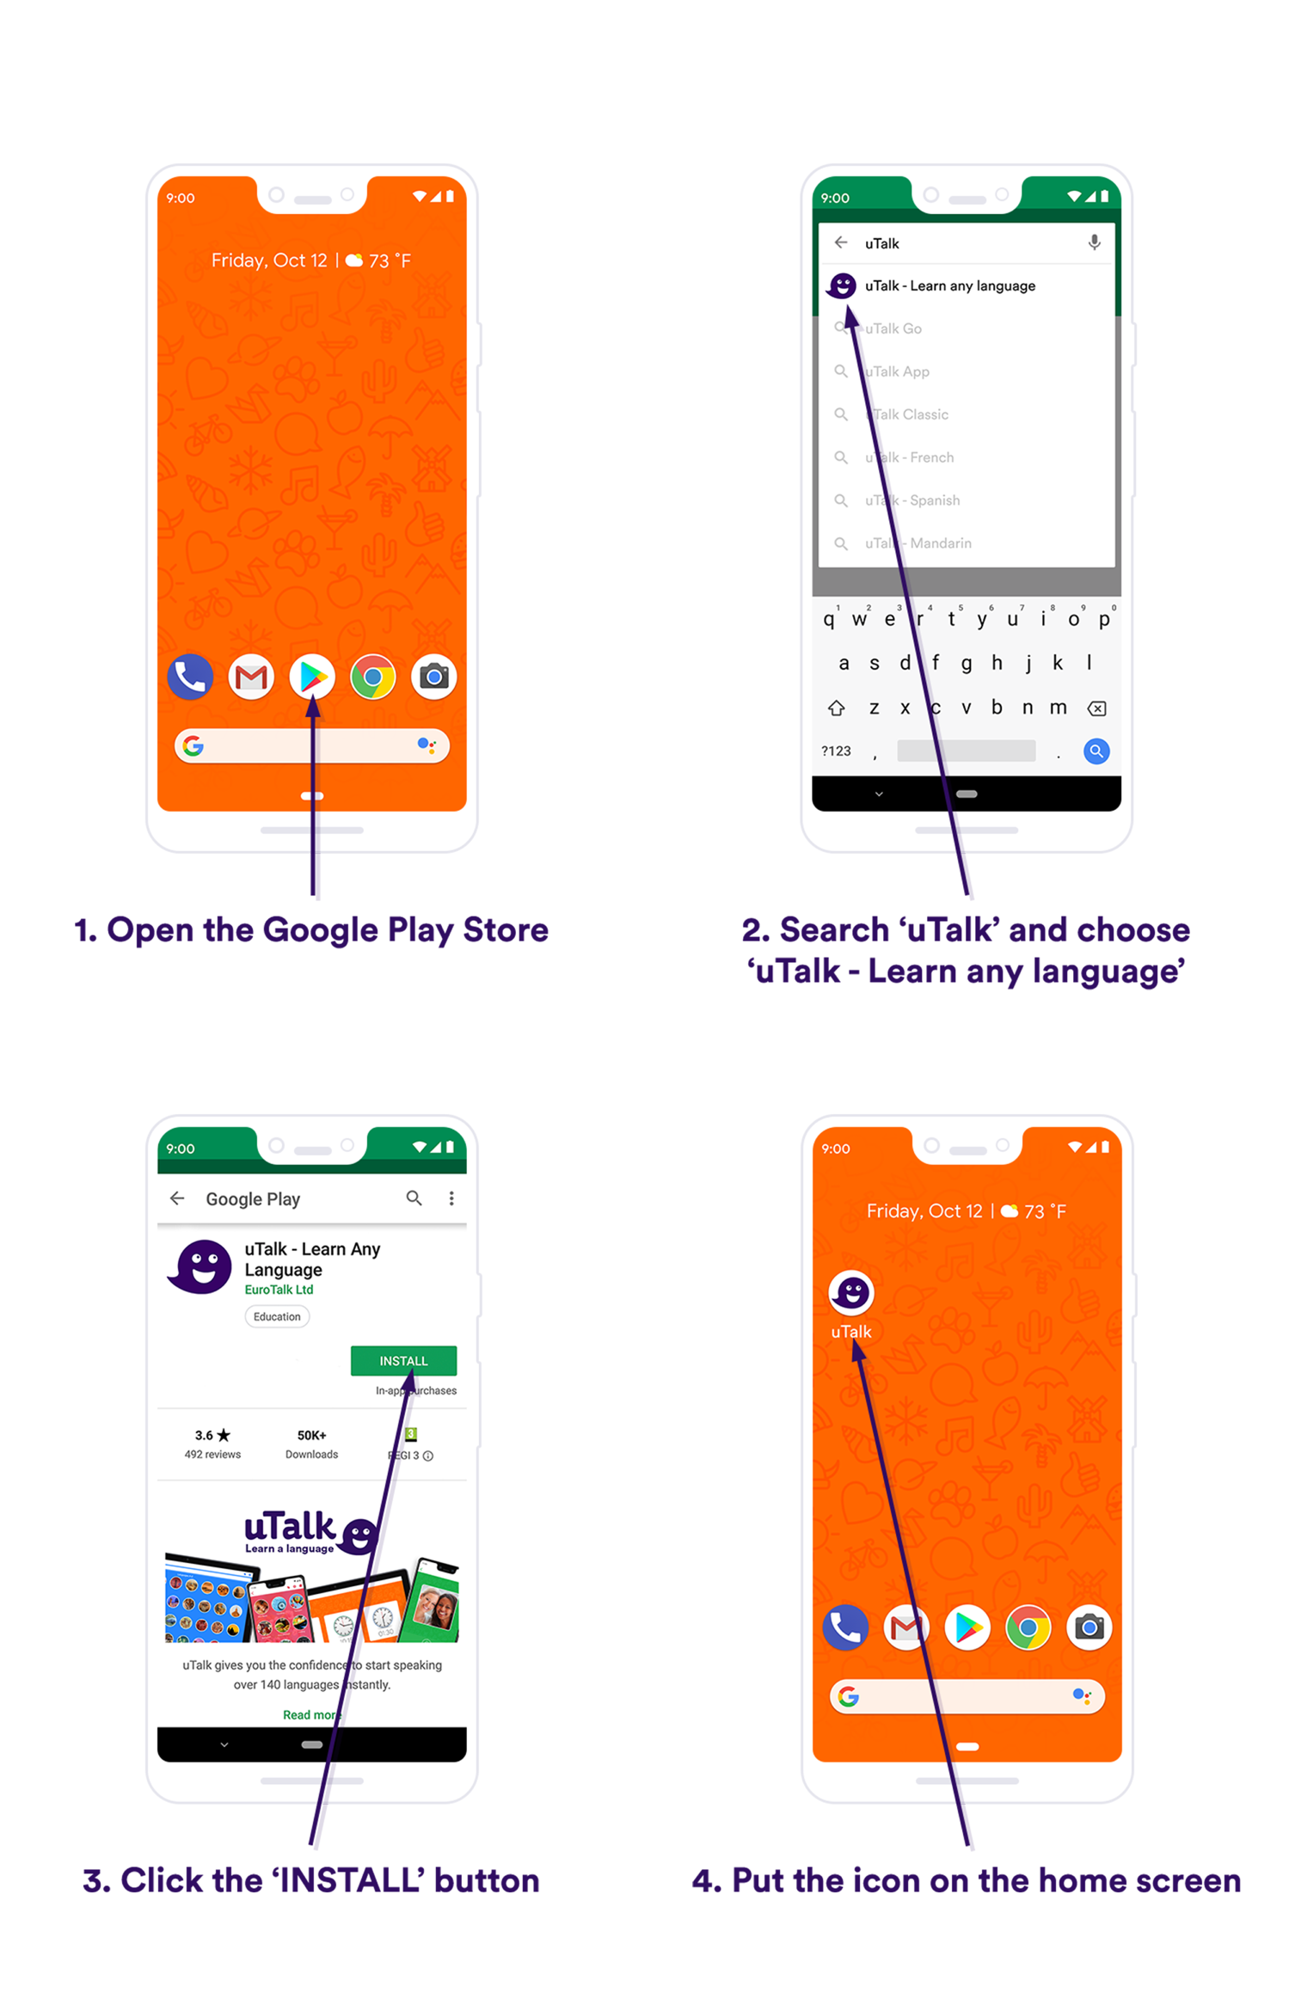
Download the App – Android

Download the App – Mac

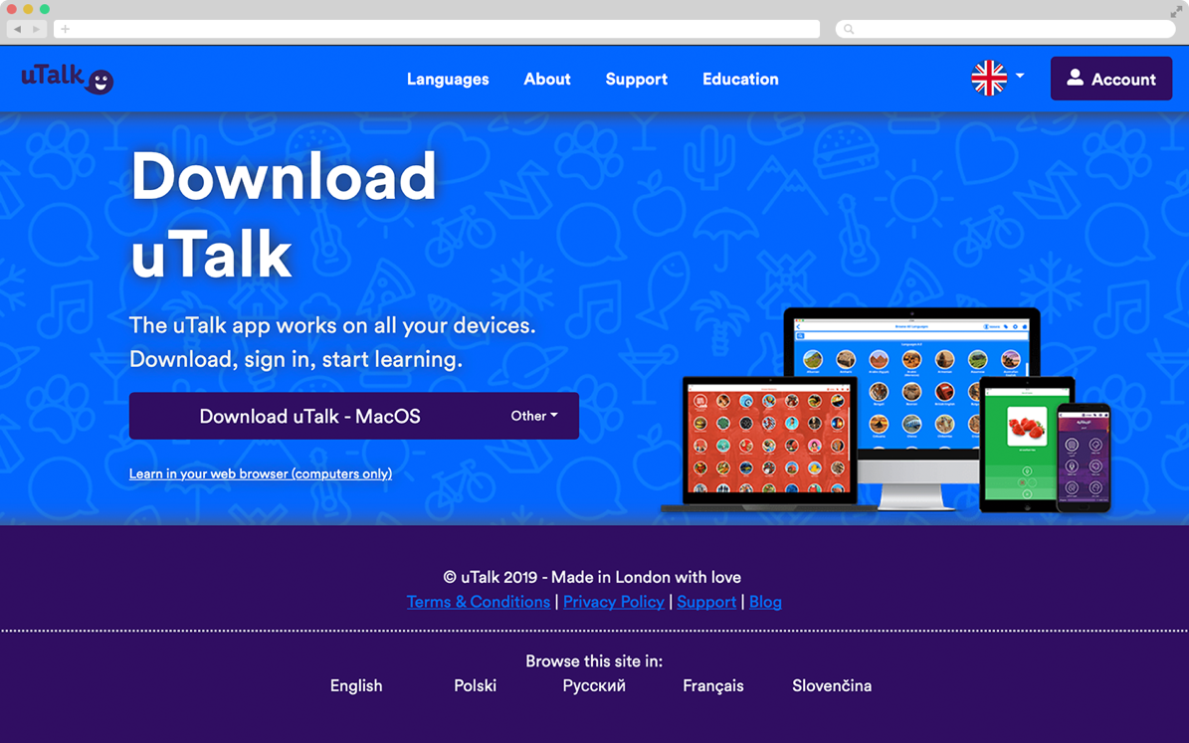
1. Go to utalk.com/app. The ‘Mac OS’ should be detected automatically. If not, select it from the drop-down menu and click ‘Download uTalk – MacOS’.
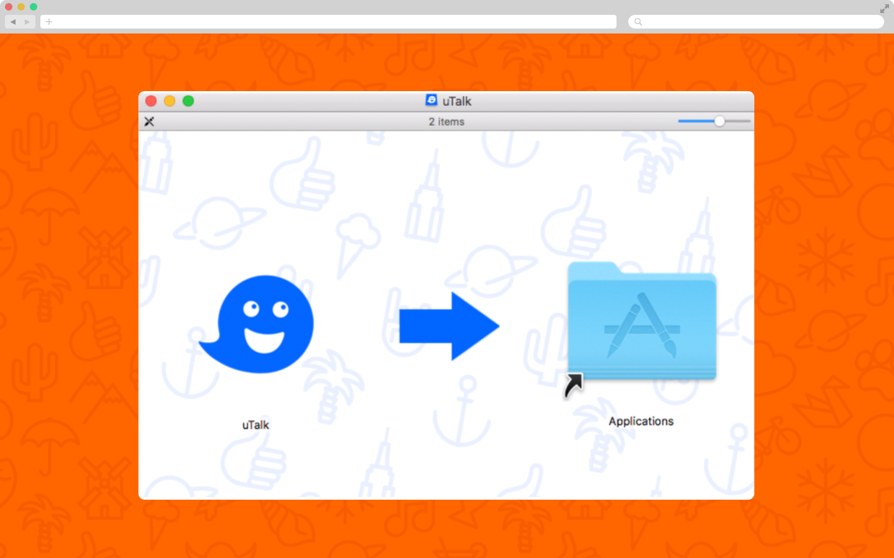
2. Once the download has finished (it should be in your downloads folder), click it to open and show the screen above.
Drag and drop the uTalk logo into the applications folder to install then go to your applications folder and open the app.
Download the App – PC

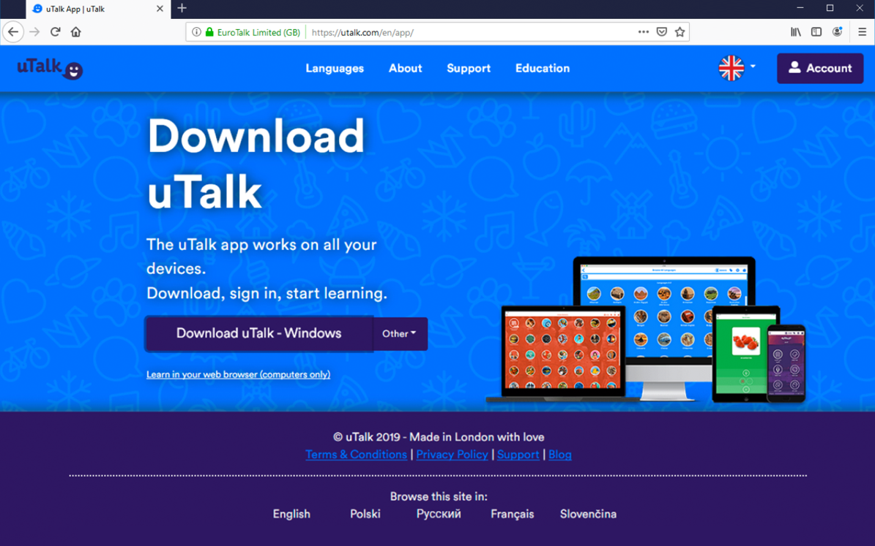
1. Go to utalk.com/app. ‘Windows’ should be detected automatically. If not, select it from the drop-down menu and click ‘Download uTalk – Windows’.
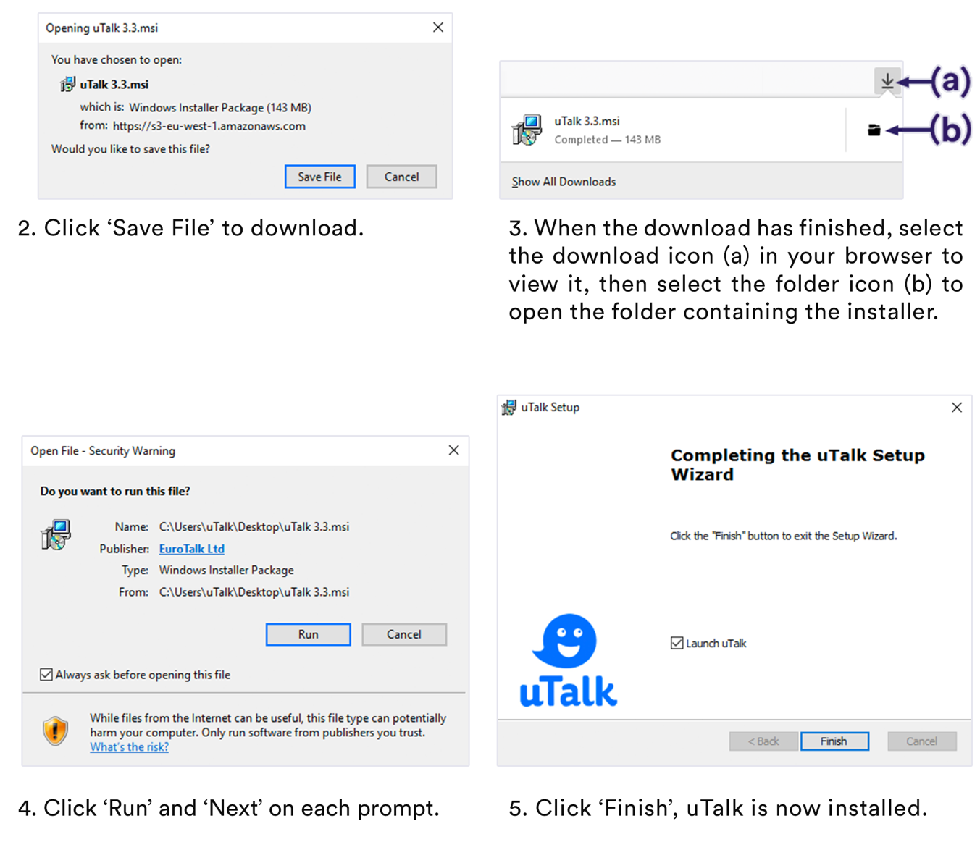

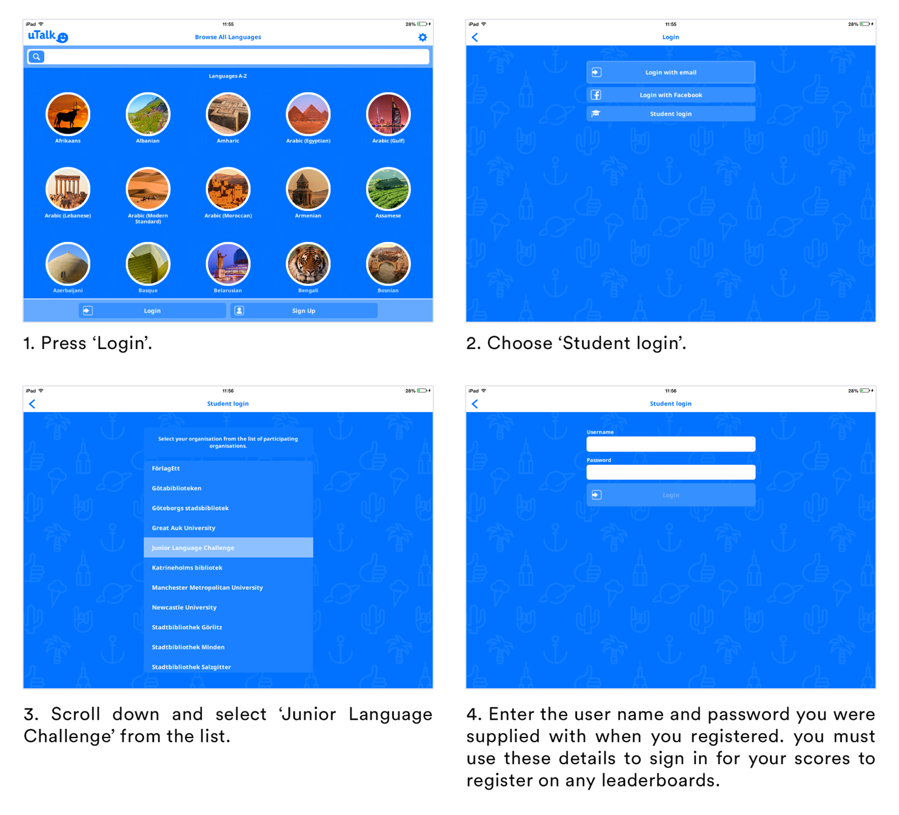
Logging in to the App

Dashboards
The dashboard is an online tool used to register pupils, track points, view achievements and get support in the uTalk JLC.
Dashboards are available to both entrants and teachers and are accessed by logging in to your uTalk JLC accounts at utalk.com/jlc and using the username and password you were supplied with / set up at registration
Student Dashboard
Pupils entered as part of a school will have access to a ‘School Dashboard‘. Here they can view their current score as well as the ‘Leaderboard’ of scores and ranking for everyone registered to the uTalk JLC at their school.
Individual achievement badges will be displayed under the ‘Achievements’ tab and will also show the amount of points needed to gain further achievements.
There is a ‘Support’ tab with details on how to get in touch as well as a buttons to download the app or reset passwords.
Teacher Dashboard
School teachers will have access to the same ‘School Dashboard’ as their pupils’ but with the addition of a ‘Register Pupils’ tab.
This online form can be used to easily register multiple students to the uTalk JLC.
Individual Entrants Dashboard
Individual entrants will be able to view their ranking on their regional dashboard.

Downloadable Resources
To help you get the most out of the uTalk JLC we have provided a number of resources which you are free to download and use.
These free materials can be found at utalk.com/JLC, under the ‘Resources’ link in the site navigation. They include -
- A template letter and consent form to send to parents which details the competition.
- A Registration form to collect student details to make your life easier when registering them via the online dashboard.
- A Certificate of Participation which can be printed and given to all the children taking part in the uTalk JLC.
- A template containing the full set of achievement badges which can be printed on to Avery sticker paper (Templates – 5293 and E3613) to create fun stickers for the children to collect. *
- A flyer and poster to help promote the uTalk JLC around your school.

* We have created some fun achievement stickers to celebrate different score milestones. There are 24 of them in total and a different one will be earned every time a pupil clocks up 165 more points on the app (equivalent to half a topic). Use our template to print out and award as appropriate. In Round Two, which has more topics, so therefore has a higher total maximum score, the increment between stickers is 220 points.

Contact
We hope this guide has answered any questions you may have had about the uTalk Junior Language Challenge. If something still isn’t clear you might be able to find the answer by viewing our FAQ’s at utalk.com/JLC or contacting us directly at challenge@utalk.com.
Keep an eye on all of our social media for updates, and use #utalkJLC to get involved.

